4.0 | Contextual Synthesis

4.1 Preamble
The historical context of the Yarrangobilly Precinct, the karst system and associated topography, Caves House and its grounds, physical evidence and associated issues are key aspects in its significance assessment. The historical background provided in section 2.0 together with the physical analysis in section 3.0 and the following synthesis places the establishment and development of the Precinct and its features in the context of its place in the development of the State and the Nation. The conclusions reached in this section build on the thematic framework established in Section 2.0.

4.2 Synthesis
Prior to undertaking the significance evaluation, the context of the physical and fabric evidence is examined to identify evolution, associations and historic occupations and to establish the significance of individual elements.
Consideration of the context of the Yarrangobilly Precinct requires:
- Understanding of the significance of the development of Yarrangobilly as a tourist experience in the context of the development of the tourism industry and nature based and cave related tourism in Australia in general and in the Kosciuszko region in New South Wales in particular.
- Analysis of the architectural character of the Yarrangobilly Caves House complex within the context of comparative period tourist accommodation houses.
- The importance and rarity of the karst system and the associated vegetation and topography in the context of other karst systems.
- The significance of the Yarrangobilly Precincts' association with the local Aboriginal people and with historical Aboriginal occupation and culture.

4.2.1 Understanding of the significance of the development of Yarrangobilly as a tourist experience in the context of the development of the tourism industry and nature based and cave related tourism in Australia in general and in the Kosciuszko region in New South Wales in particular.

Tourism
A brief look at the historical evolution of tourism described by Lickorish & Jenkins (1997), Rosenbaum (1995), Urry (1990), Feifer (1985), and others, shows the opportunity for tourist experiences moving from small elite upper social classes through the professional classes to the proletarian masses in developed western countries. Third world countries and societies have become the ‘new’ destinations with their cultures becoming the ‘new’ attractions.
Documented travels with touristic characteristics commence with Roman excursions. Early travellers were typically individuals or small groups who were purposeful and motivated by special interests. The tourist juggernauts of the thirteenth and fourteenth centuries immortalised by Chaucer, were the pilgrimages, which introduced tourism as a group experience. The Grand Tour that became an essential component of the education of the English nobility, was firmly established by the end of the seventeenth century, and was then adopted for the sons of the professional middle classes.
‘Over this period... treatises on travel shifted from a scholastic emphasis on touring as an opportunity for discourse, to travel as eye witness observation’ spurred on by ’the growth of the guide books which promoted new ways of seeing’
The character of the Grand Tour itself shifted from the earlier ‘classical Grand Tour’ based on emotionally neutral observation and recording of galleries, museums and high cultural artefacts, to the nineteenth-century ‘romantic Grand Tour’ which saw the emergence of ‘scenic tourism’. Scenic tourism reflects the rise of the ‘picturesque’ a component of the Mannerist movement where whole landscapes were sculpted by the likes of ‘Capability’ Brown and other ‘gardeners’ and pseudo classical ruins and medieval buildings were artfully presented in those landscapes in a spirit of unabashed make believe.
In the eighteenth century spa towns in England and Europe associated with the coast and sea bathing, acted as health resorts and provided an important social milieu. The earliest resorts in mainland Australia were in the mountains because people valued air that was purer and cooler than in the city.
In New South Wales, Yarrangobilly, Jenolan, Wellington, Abercrombie, Bendithera, Bungonia and Wombeyan caves were all developed in the late nineteenth and early twentieth century in the period when Scenic tourism was in the ascendance. With their combinations of rugged and picturesque topography and the dramatic and mysterious underground cave formations Yarrangobilly, Jenolan and the other karst environments had strong appeal for the Victorian sense of the dramatic and romantic.
The Blue Mountains, Jenolan Caves, the Dandenong Ranges , Tambourine Mountain and Mount Lofty Ranges were particularly popular with honeymooners. In the 1870s Sydney holiday makers took Cobb & Co coaches to Katoomba; in the 1880s the opening of the railway increased the resorts popularity…Some of those who headed for the heights had more athletic pursuits in mind than taking the mountain air. A hotel was built at Mount Kosciuszko New South Wales in 1909 and a Chalet at Mount Buffalo (Victoria) in 1910 mainly for summer recreation but hardy adventurers explored the mountains on skis during winter.
Thomas Cook organised his first pleasure excursion in 1844, and set the foundations for the subsequent proliferation of package tours. The organised group tours provided a level of surety and personal safety that was not otherwise available to the inexperienced, or new traveller. Those holidays were also characterised by annual returns to the same place by the same people and Urry notes that a particularly significant features of such holidays was that it should be enjoyed collectively. Previously holidaying had been the province of the wealthy. Where the holiday was taken became a finely tuned social discriminator associated with status. Within this genre of mass market holidays and holiday destinations as finely tuned social discriminators, Yarrangobilly and Jenolan being difficult to get to and having limited accommodation had a select and comparatively wealthy repeat professional clientele. Other more accessible and less topographically restricted places like the Blue Mountains resorts were able to expand their accommodation to cater for the mass market.
Yarrangobilly and Jenolan have significance beyond cave tourism. They are early also sites that combine tourism with specific aspects of the Australian landscape and with the public transport (rail) system. The development of tourism at these cave areas, as well as places of scenic splendour such as the Blue Mountains, was associated with rail based tourism, and they are probably amongst the first examples of nature-based tourism in Australia (or at least New South Wales). Tourism in the late 1800s "evolved" as part of a "movement" that was encouraged by successful "marketing". Some of the advertising material is quite interesting and may indicate a deliberate campaign by Government Railways, rather than just being a consequence of increased leisure time. The late 1800s was also a time of Mechanics Institutes and the establishment of sporting and recreation clubs. Such institutes and clubs contributed to continuing adult education and provided the basis for organised group outings to places like Yarrangobilly and Jenolan Caves.
Modernism, begins in the 1900s. Central to modernism is the view of the public as a homogeneous mass. Touristically this period saw the internationalisation of the tourism experience. Conversely this period also translated into a process of differentiation … between the elite and mass forms of consumption.
Modernism arrived on the back of technological changes in aviation and computerisation and an overall rapidity of change not previously experienced. It embraced long distance travel, a business travel network and cheap mass travel.This period saw a number of international visitors making their way off the beaten track to Yarrangobilly and a steady stream of bus tours, which stayed for two days. However, the decline of the physical fabric of the asset over time caused Yarrangobilly to be shut down and during this process the site lost much of its profile in the market place and the loyalty associated with return visitation.
Post-Modernism involves the continuation of Modernism and its transcendence... Post modernism means the end of a single worldview and, by extension a ‘war on totality’ a resistance to single explanations, a respect for difference and a celebration of the regional and local particular. Yet in the suffix ‘modern’ it still carries the burden of a process which is international and in some senses universal.
Within the Post Modern context, cave related experiences are generally recognised as local and authentic because by their nature the cave related experience is local and particular. It is also elitist, having a low visitor capacity and at the same time the appreciation of the aesthetic experience is a personal one. To a large extent this period has seen the decline of cave related tourism as electronic amusements have replaced the imaginative stimulation previously provided by scenic and cave visiting experiences.

Artists and Nascent Nationalism in Seeing the Caves
During the 19th century numerous artists attempted to capture the essential nature of caves. In the earliest images caves were portrayed as places of adventure, mystery and beauty, coupled with scientific interest and curiosity. Although artists attempted to reproduce the caves precisely, they typically brought additional elements to the subject. Elery Hamilton Smith, in an article titled 'Seeing Australian Caves.' in the Journal of The Sydney Speleological Society, 1990, 34(3) examines the way caves have been portrayed and subliminally marketed to the public.
Mitchell, it has been argued, focused interest on the cave decoration, but also conveyed his sense of wonder and beauty and even the sublime. Conrad Martens used fine draftsmanship to convey his sense of the beauty of the great Arch at Burrangallong (Abercrombie) but did not include human beings. This, Hamilton Smith suggests, leaves the observer with a more detached feeling than when viewing Mitchell's work. He quotes the argument that there is a complex inter-relationship between pain or discomfort and pleasure or comfort. One expression of this is that things, which frighten people by their scale or mystery, become transformed in the mind to something sublime and beautiful. In turn, this often leads to the landscape being reconstructed as bigger and more grandiose than in reality.
An example quoted is Negri's engraving of Carlotta Arch published in Garran's Picturesque Atlas. This was almost certainly engraved from a photograph, which gave no indication of scale. When human figures were added the Arch appeared immense, certainly precipitous and frightening - an expression of artistic expectation. Caves were clearly expected to be large and magnificent. (Hamilton Smith suggests a 'conspiracy theory'. Excluding people obscured the scale, consequently images looked much more magnificent than in reality. Hamilton-Smith gives the example of a painting c.1905, based on Kerry’s photographs. It depicts visitors 'gazing up in awe at a monstrous Nellies Grotto, when the real scene is only knee-high!')
It is also suggested that the absence of human beings in Charles Kerry's images might have been deliberate - perhaps he was seeking an idealised vision of nature unaffected by human beings. Pristine caves fitted this vision perfectly. They dominated his cave photography and most of his landscapes. The significance of the sublime is indicated by the fact that many of his photographs are taken from a low angle looking upwards.
It has further been suggested than Kerry's sense of the sublime in the grandeur and majesty of the Australian landscape represented a tradition, which had emerged from the nascent nationalism of the nineteenth century. The struggle for a sense of independent national identity, and the desire to demonstrate that Australia equalled or excelled the rest of the world.
Other images combined scientific illustration with the portrayal of visitors, giving the work a sense of the human experience. Yet others showed the picturesque character of the Australian landscape and cavescape. For some, the idea of the sublime was linked with the new enlightenment, and had a major influence on landscape artists in Australia.
The end of the century saw what Hamilton-Smith termed 'the industrialisation of caves' to provide attractive destinations for the relatively new tourism industry. This coincided with new technologies in photography and printing, which enabled the mass production of images. Consequently images came to be used as a marketing tool. An example is Jenolan, the country's foremost tourist resort at the time. The new and remarkably powerful picture postcard became available in many millions of copies, with some fifty per cent of all Australian postcard images of caves portraying Jenolan.
This also indicated a change in the public perception of caves. The industrial images had to convey a sense of comfort and security, and to help people see the cave as a safe and welcoming place of readily appreciated beauty, rather than one of adventure, mystery or even fear. This was reflected in cave photography, including the work of the Blue Mountains photographer Harry Phillips. Phillips often included people in his photographs. It is suggested that he was responding, consciously or unconsciously, to the photographs taken by the visitors themselves. In their snapshots people predominated, with the caves and associated landscapes providing a backdrop.
Phillips, Hamilton Smith suggests, was a publicist for the mountains as a friendly picnic ground. His mountain views show people looking down from the peaks, or picnicking in the valleys. Although people rarely appear in cave photographs, "he moved in close to his subject, looked directly at it or even down upon it, and emphasised even more than Kerry the textures which delighted the visitor. He aimed at intimacy rather than grandeur.'
Hamilton Smith points out that when A. H. M. (Tant) Bradley was chief guide at Jenolan Caves his photographs also viewed the cave as the visitor actually saw it, 'although he took pains to seek out the viewpoint which excluded the then abundant artefacts, such as wire netting'.

Cave Tourism
Cave related tourism promoted by nineteenth century photography and artistic interpretations took the form of guided cave visits and group tours. It was the safer and sanitised extension of cave exploration.
Indians in Kentucky are known to have explored the Salts Cave 4000 years ago to extract gypsum and mirabililte for medicinal use and as a base for paint and the Mayans used caves in Mexico and Guatemala. In several places in Australia Aboriginals mined caves for flint for tools. The only one of those sites accurately dated is Koonalda Cave (Nullabor) where there was human activity from roughly 22,000 to 15000 years ago up to 130 metres from the entrance.
Modern speleology emerged around the 17th and 18th centuries. Motivations have been primarily scientific but since World War II, sport has been a major factor in cave visitation and exploration. Caving of one sort or another, diving, rafting and long distance travelling has acquired an important place in adventure tourism.
The first systematic exploration of cave systems took place around the turn of the 18th century, for example Baradla barlang in Hungary beginning in 1794 and Mammoth Cave in the United States in 1802. Karst regions were also explored, the Carniole (corresponding today to the karst of Yugoslavia and Trieste) is considered the birthplace of European speleology. The growth of the interest in cave systems is largely attributed to the desire of a return to nature and the increasing amount of leisure time available to people in industrial nations.
The beginning of karst documentation in Australia occurred when the explorer Evans on May 21, 1815 discovered the first limestone in New South Wales located at Walli. Evans and subsequent explorers including Oxley, Mitchell, Grey, Eyre and Forrest to name a few featured prominently in the discovery of caving areas. However, many caves were also found by straying stock and by happenstance.
Interestingly the Government Surveyor Oliver Trickett is perhaps Australia’s closest counterpart to Martel, a French cave explorer and writer from 1888 to 1913 who is recognised as the father of speleology in Europe. In the beginning of the 20th century Trickett mapped and described most of the known caves in New South Wales. He also wrote the first guide to the Yarrangobilly Show Caves. Other early guides are also recognised as having made major contributions to the development and promotion of great caves in Australia. They are J Wilson and J Wibard of Jenolan, A Bradley and L Hoad of Yarrangobilly, L Guymer of Bungonia, W Redden of Naracoorte and F Moon of Buchan all of whom took an exceptional interest in caves and their exploration and contributed to their popularity as tourist destinations.
The major tourist or ‘show’ caves of Australia today are Jenolan, Naracoorte, Wombeyan, Yarrangobilly, Buchan, Yallingup, Yanchep, Abercrombie, Mole Creek, Hastings and Chilligoe. Of these only Jenolan, Yarrangobilly and Yallingup have surviving Caves Houses, which historically accommodated cave visitors. Many caves were found early in the nineteenth century but only a few of the more spectacular ones were proclaimed reserves and opened to the public. The earliest reserve in New South Wales made to protect a karst landscape was at Wombeyan in 1865 and a Keeper was appointed in 1868. An accommodation House was constructed at Wombeyan in 1889, which was destroyed by fire in May 1934. The next caves reserve was proclaimed for Jenolan Caves and the first Keeper appointed in 1867. Construction of Jenolan Caves House took place in 1887. Naracoorte Caves [NSW], which are now on the World Heritage List, were opened to the public in 1884 as was Queensland’s Capricorn Caverns (also known as Olsen’s Caves). Then in 1887 a guide was appointed at Yarrangobilly in the Snowy Mountains and it was opened to the public in the same year as Waitomo in New Zealand was opened. Abercrombie Caves were opened to the public and a caretaker appointed in 1888. In Western Australia Ngilgi Cave at Yallingup, Yanchep Cave and the Augusta Margaret River Caves were opened to the public in 1900, 1903 and 1904 respectively. The opening of show caves slowed dramatically after the turn of the century. In Australia in the 1920s speleology became somewhat dormant as a popular interest. In the 1920s only one cave group, the Kelly Hill Caves on Kangaroo Island in South Australia were opened [1926] to the public and in the 1930s [1931] Tanatanoola Caves also in South Australia were opened. However, during the 1930s an increasing number of newspaper reports including scenic photographs and newspaper reports and diaries by keen bushwalkers such as O Glanfield reawakened interest. Hastings Cave and its associated thermal pool in Tasmania were not officially opened to the public until 1939. Many of the smaller show cave developments now open to the public have been opened in the last ten years.
Many of the Keepers or caretakers in the nineteenth century had on site accommodation so it is likely that they provided limited accommodation for visitors. It is interesting that among the profusion of cave attractions opened in the nineteenth and early twentieth century, only four are known to have offered substantial on-site accommodation. They are Jenolan whose complex of accommodation buildings commenced with Caves House constructed in 1887, Wombeyan whose Caves House was opened in 1889 but was destroyed by fire in 1934, Yarrangobilly whose Caves House was opened in 1901 and at Yallingup in Western Australia where the Caves House is also thought to be early twentieth century.
The oldest caving club in Australia is the Tasmanian Caverneering Club, formed on September 13, 1946, while the Sydney University Speleological Society was formed on September 22, 1948. Cave diving began in the late 1950s in areas such as Jenolan and in Tasmania.
More recently the loss of the sense of ‘wonder’ that accompanied cave visitation and discoveries is a factor recognised by modern cavers.
Twenty years ago we were astounded by a new cave over 500m deep. Today a new 1000 metre cave is greeted with relative indifference.[p16 Courbon et al, Atlas of the Great Caves of the World 1989]

Conclusion
Within the development of the tourism industry, cave related tourism in the form of guided tours is a late nineteenth century phenomenon associated with the Mannersist Movement and the popularity of Scenic and nature tourism as popularised by local artists and photographers. Within the rise of Scenic Tourism in Australia, Yarrangobilly was one of a small set of cave destinations modelled on the small resort or spa promoted by Government Agencies including the railways.
Yarrangobilly has a strong association with Oliver Trickett who is recognised as the father of caving in New South Wales. The site was for its formative years in the care of A Bradley one of a small group of cave site guides and caretakers recognised for their exceptional interest in caves and in cave exploration. Trickett, Bradley and Hoad made a considerable contribution to the popularity of Yarrangobilly Caves as a tourist destination.
Trickett, Kerry and Tant Bradley all contributed to the promotion of the site with their artistic photography and post cards which reflected the nascent nationalism of the nineteenth century. The struggle for a sense of independent national identity, and the desire to demonstrate that Australia’s natural scenery equalled or excelled the rest of the world.
Yarrangobilly is the earliest of the tourist resorts established in the Kosciuszko mountains, the others being the Kosciuszko Hotel and the Creel-at-Thredbo, which were established in the period 1906-1909. Yarrangobilly had a loyal following of visitors primarily from professional society who returned on an annual basis. It was probably second only to Jenolan for its recognised potential as a tourist experience. In 1897 Oliver Trickett wrote:
…it is not unreasonable to suppose that the impressive scenery, the number and extent of the caves and the cool climate in this locality will render it in future one of the most popular resorts of tourists in the colony. [p203 NSW Mines Report 1897]
It is one of only three cave systems in New South Wales to have a purpose built accommodation house constructed close to the caves.

4.2.2 Analysis of the architectural character of the Yarrangobilly Caves House complex within the context of comparative period tourist accommodation houses.
The accommodation at Yarrangobilly evolved from three cottages, which housed the caretaker/guide and offered accommodation to guests to a purpose built facility designed by the Government Architect and constructed in 1901. Walter Liberty Vernon, had been appointed Government Architect on the 1 August 1890, and remained in the appointment until 11 August 1911. His architecture relied for its character not so much on formal symmetry but on the balanced arrangement of masses and forms arising out of flexible plans and using plain materials with little applied ornamentation. Vernon’s buildings were the precursors of the architecture of the twentieth century and he was one of the founders of what was later known as the Federation style.
The original Caves House accommodation was expanded between 1913 and 1917 with the addition of the two-storey wing designed in 1912. The complex was substantially altered again in 1938 then in 1960s after the demolition of the kitchen and other structures east of the complex and the conversion of the 1919 Caretakers Cottage to a Visitors Centre.
The original Caves House is a one-storey timber structure built of timber in the Victorian Italianate style. It is an asymmetric gable roofed composition with a protruding gable front on its west-end and a sweeping verandah along its north façade which was extended in 1938. The long shadowed verandah on the front (northern) façade of the building is a strong horizontal element in the composition and the building is a pleasing contrast to the vertical elements in the form of the 1912 addition and the cliff topography around it. The 1912 addition to Caves House was also designed in the Government Architects Office. Edward Lambert Drew, was the Acting Principal Architect 12 August 1911 to 24 May 1912 so it is possible that his was the major hand in the design of the Two Storey wing. George McRae, was appointed Government Architect on May 6th 1912 and remained in the post until 16 June 1923. It is also possible that GM Blair under George McRae was responsible for the design. Built over a period of five years from 1912-1917, it is a two storey gable roofed Federation Arts and Crafts style building with a romantic aesthetic arising from Tudor influences.
The Yarrangobilly Caves House complex is a low key composition made from readily available and easily transportable timber materials yet it manages to convey a sense of the past and a sense of romance. Other comparable tourist accommodation buildings from the same era are Jenolan Caves House, the Hydro Majestic Hotel in the Blue Mountains, the Mount Buffalo Chalet in Victoria and the Kosciuszko Hotel. Other isolated mountain resorts of the period,

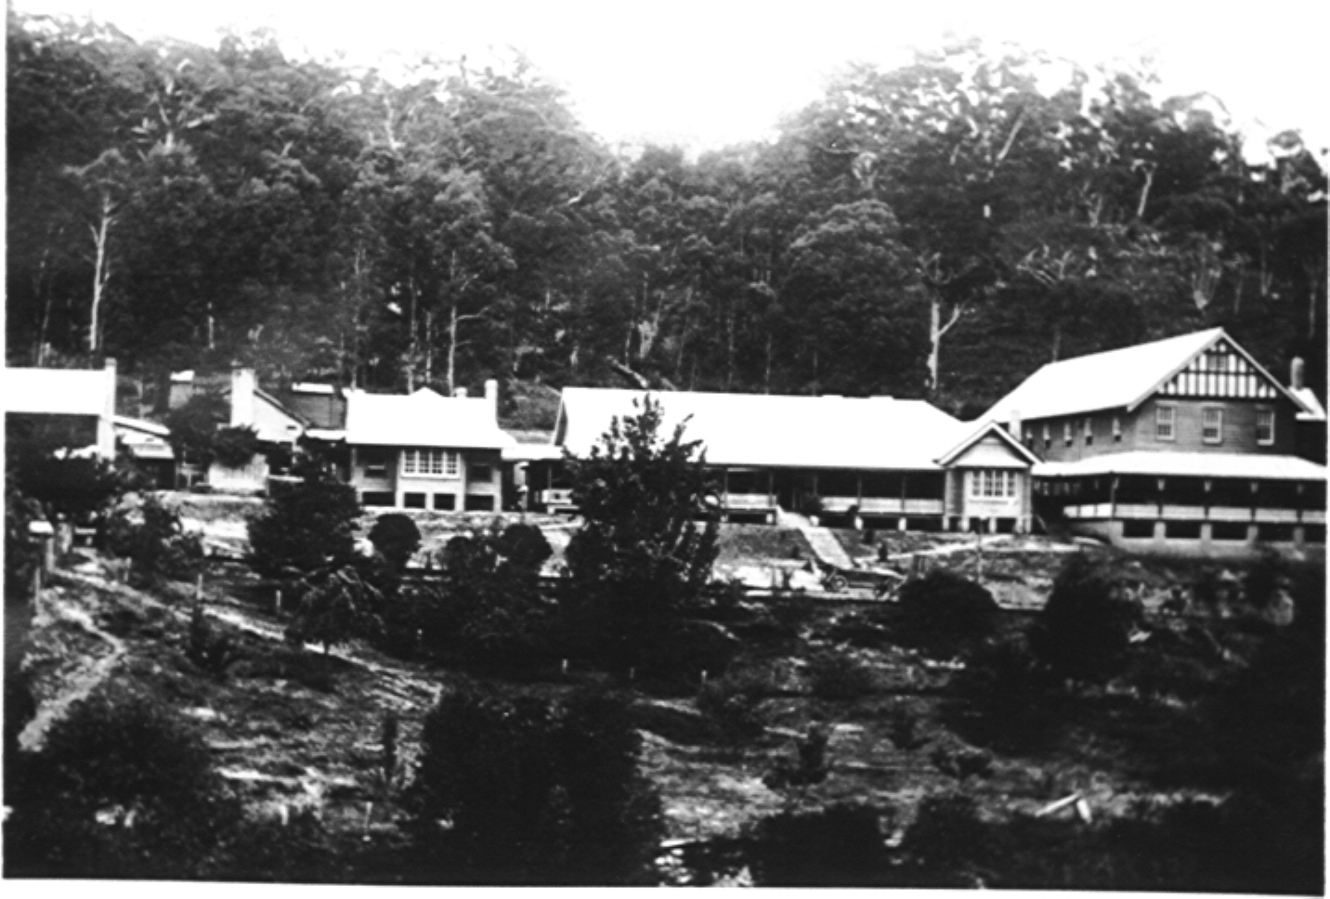
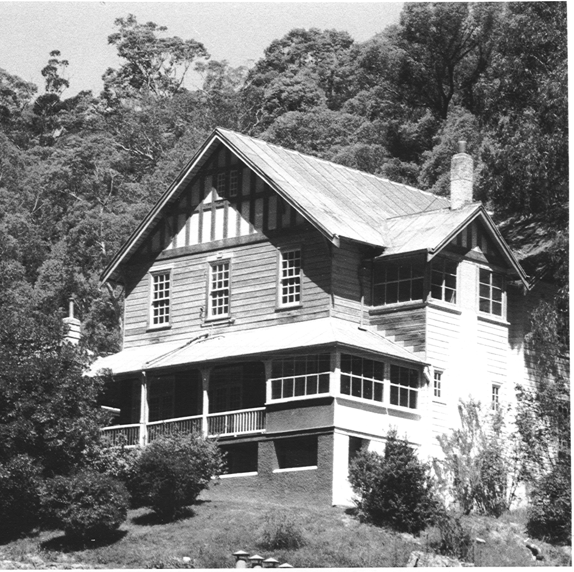
Figure 4.1 The Yarrangobilly Caves House complex c.1937 [Photograph from the NPWS Yarrangobilly photographic Collection donated by C McDonald]
1912-17 Wing
1901 Caves House
c.1936 Dining Room
Kitchen
Lessees residence
Figure 4.2 The Two Storey Wing [Undated photograph courtesy of the Tumut Historical Society]
designed in the Government Architect’s office include Jenolan Caves House [1887] and the Mount Kosciuszko Hotel [Chalet] c.1909, which although generally on a grander scale, were in a similar romanticised Arts and Crafts Tudor influenced Federation architectural style.
The Caves House complex at Jenolan includes a gable roofed two storey rusticated sandstone building with verandah roofs over the ground floor front public spaces. It also has a contrasting vertical element in the form of a four-story accommodation wing with a rusticated base and tudoresque top with comparatively simple Federation style middle floors. See Figure 4.4. It is a much larger and grander complex than Yarrangobilly, but nestled in the picturesque valley the historic buildings share many of the same aesthetic features exhibited at Yarrangobilly. There is a conjunction of strong horizontal and vertical elements, in a romanticised Federation Arts and Crafts architectural style with Tudor influences and locally available materials were used. Similarly the Kosciuszko Hotel (completed c.1909 and destroyed by fire in 1951) was constructed as a two storey gable roofed, timber Federation Arts and Crafts building with sweeping verandahs at ground floor level.
The Hydro Majestic Hotel on the other hand like many of the grand hotels of the period was constructed to a much grander vision by a private person rather than as a government service. Mr Mark Foy had returned from a trip abroad where he had received treatment at Matlock Bath in England eager to introduce the nature treatment to Australia. He purchased the palatial Belgravia Hotel built in 1891 and adjoining properties and redeveloped the site adding a casino and staff quarters. The hotel was opened in July 1904 with visitors able to travel only as far as Penrith by train and being conveyed in a fleet of open cars on the final leg of the journey. However, it wasn’t until Foy dropped the idea of hydro-therapy and made the hotel into a family hotel that it started to boom. In the early twentieth century the hotel was fully booked with more than 70,000 guests a year. Architecturally the hotel reflects its composite origins and is clearly composed of a linear arrangement of several buildings in different styles, but they are all grand and imposing architecturally. The preponderant style on the public buildings is Victorian and Federation Free Classical. However, some sections also have a strong Arts and Crafts and Queen Anne influence. This is a more solid and more classical architectural statement than the Hotels and accommodation Houses produced by the Government Architects branch. With its classical references and lavish appointments it reflects the European inspired vision of an antipodean spa that Foy returned with, rather than celebrating the romance of scenic beauty in the way the simpler government tourist accommodations did.
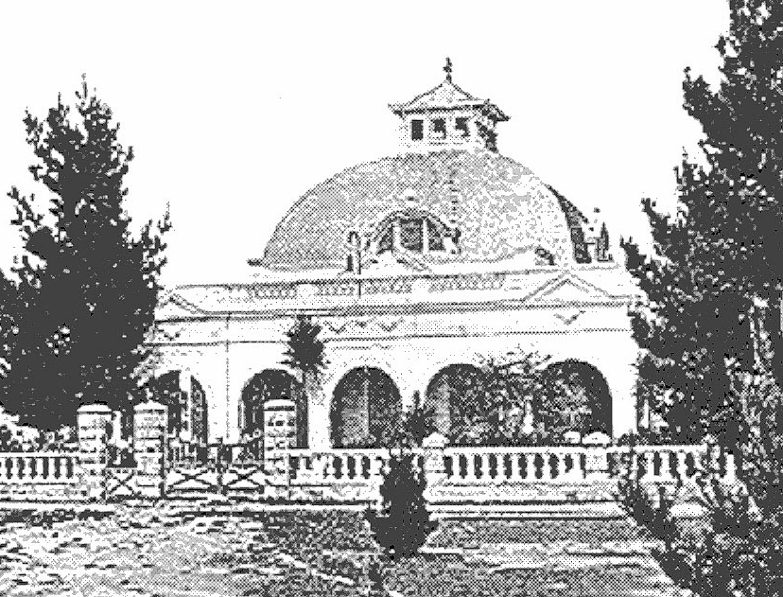
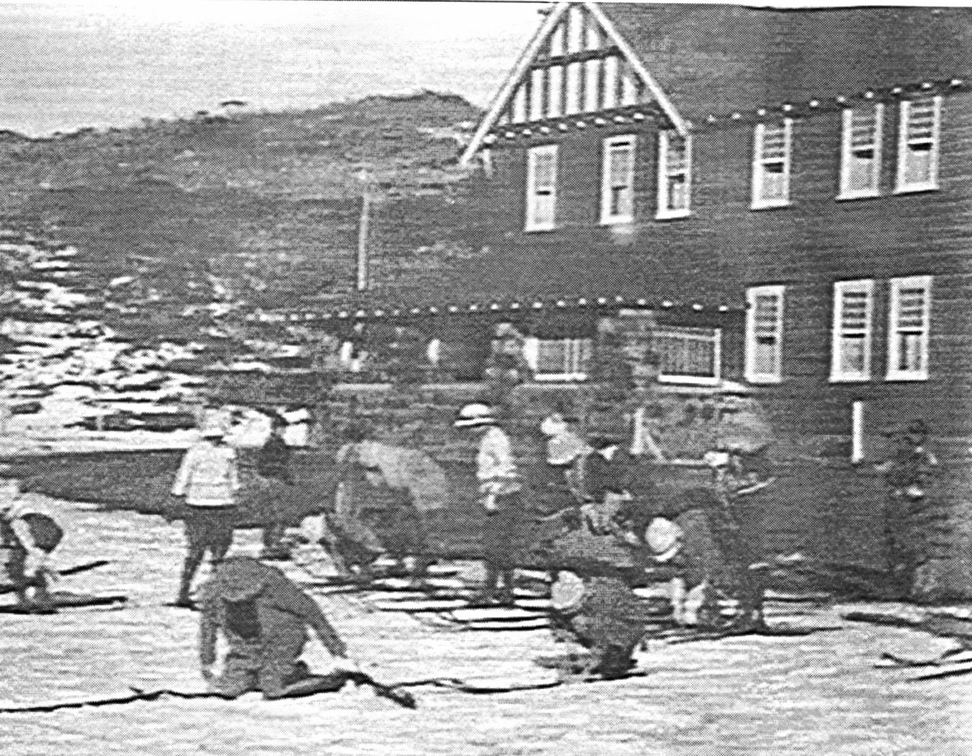
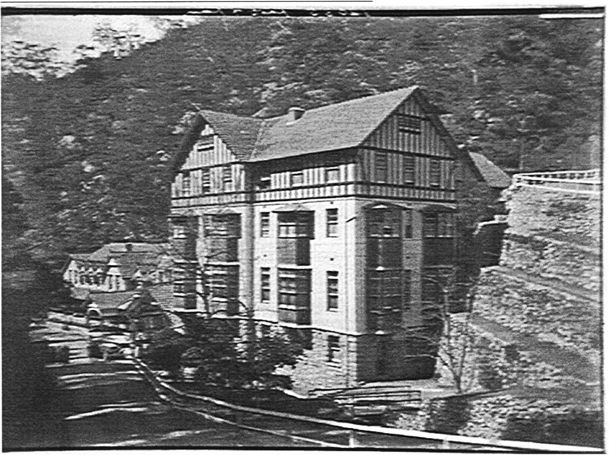
Figure 4.3 This photograph shows skiers preparing to move off from the Chalet at Charlotte’s Pass which was built in a similar style to the Kosciuszko Hotel. [Photograph courtesy of the Mitchell Library]
Figure 4.4 Caves House at Jenolan.
[Photograph courtesy of the Mitchell Library]

Figure 4.5 A view of the ballroom and grand dining room at the Hydro Majestic Hotel, Medlow Bath Blue Mountains.
[Photograph from http://bluemts.com.au/hydro/welcome.htm]
Figure 4.4 Caves House at Jenolan.
[Photograph courtesy of the Mitchell Library]

Figure 4.3 This photograph shows skiers preparing to move off from the Chalet at Charlotte’s Pass which was built in a similar style to the Kosciuszko Hotel. [Photograph courtesy of the Mitchell Library]

Conclusion
Yarrangobilly Caves House is one of a suite of turn of the century tourist resorts designed from within the Government Architect’s Office. Although varying greatly in size the Government built tourist accommodation houses all exhibited a characteristic romanticised Arts and Crafts Tudor influenced Federation architectural style. Because of their isolation they were all constructed using locally available stone and timber. This was at a time when most private enterprise tourist developments were substantial developments in Free Classical styles that competed for attention with their often spectacular settings, rather than complementing their settings and celebrating scenic beauty as did the simple Government designs.
Yarrangobilly Caves House is a good representative example of the Government Architects Office’s turn of the century designs for Alpine tourist accommodation.

4.2.3 The importance and rarity of the karst system and the associated vegetation and topography in the context of other karst systems.
Caves systems in Australia are discussed in the Historical Background Sections 2.4 and 2.5, 2.10 and 2.19. In New Zealand there are two major caves areas Waitomo on the North island made famous because of its glow worms and on the South Island North West Nelson. The North Island caves concentrated around Waitomo tend to be more highly decorated with stalactites and stalagmites. The South Island Caves were mostly newer more active caves with a lot of water and fewer formations. Commercial cave trips in New Zealand range from the familiar guided tourist trips, with lighting easy walkways and sometimes boat rides, to more adventurous trips involving rappelling, wet suits, waterfalls, innertubes, tight crawls and other adventure experiences.
In Papua New Guinea the largest karst region extends from the Gulf of Papua on the southern side of the island of New Guinea, north-west into Irian Jaya. It includes the Muller Range, Hindenburg range and the Star Mountains and contains three systems longer than twenty kilometres and one over 500 metres deep. A second major karst occurs on the Huon Peninsular. It is characterised by a very high altitude (over 4000m) and has high potential for deep caves.
Judgements about karst systems are very subjective dependant to a large extent on the experience of the person making the judgement. Because of this most comparison of caves is made on an easily measured technical level as outlined in the adjacent table:
*This table is adapted from information provided in Great Caves of the World.

TABLE 4.1 CAVE COMPARISONS IN TERMS OF READILY MEASURED PHYSICAL FEATURES 1989
Comparison | Name of Cave | Relevant Measure | Country | Others [in order] | Australia
Deepest | Reseau Jean-Bernard | [1494 +41] 1535m | Haute Savoie France | USSR, Spain, Mexico | Anne-a-Kananda Tasmania -373
Longest  See * Note p170 | Mammoth Cave System | Approx 530,000 m | Kentucky USA | USSR, Switzerland, USA | Tasmania, South Australia & Nullabor Plain*
Record Cave Dives (with air pockets) | Cathedral Falmouth Cave System | 10,229 m | Florida USA | Bahamas, USA, France
Record Cave Dives (without air pockets) | Doux de Coly | 3125m | Dordogne France | Australia(Nullabor), France
Tallest | Lamprechtsofeu | +995m | Austria | Switzerland, France Yugoslavia
Greatest Hydrologic System |  |  | Turkey | France, Yugoslavia/Italy
Greatest Through trips | Sistema Badalona | 1149m | Spain | France, New Zealand [Nettlebed Cave] Mexico
Largest underground Chambers [Surface Area] | Sarawak chamber | 162700m square | Malaysia | Spain, Oman Belize France
Largest underground Chambers [Volume] | Luse | 50mm square | Papua New Guinea | PNG, China
Greatest Vertical Pits | Hollenhohle | 450m | Austria | PNG, Greece, Mexico
Conglomerate caves |  |  | Spain
Chalk Caves |  |  | Nullabor
Granite Caves |  |  | New York | USA & Sweden
Sandstone Quartzite |  |  | Spain
Gypsum |  |  | Spain
Lava, basalt |  |  | Kenya | USA, Spain
Salt |  |  | Israel | USSR, Roumania, Algeria

- The fifteenth longest in Australia is the Eagles Nest Caves System of 3600m at Yarrangobilly while Jenolan has the 16th longest, Mammoth Cave.
Within the above set of readily measured parameters at an International level the Yarrangobilly Caves system and indeed caves systems in Australia generally, are not represented.
The caves at Yarrangobilly are all limestone caves. Hastings Caves in Tasmania are the only other Show Caves with a well publicised thermal pool. The Jersey Caves is noted for what Leigh described in 1892 as ‘unsurpassed for the richness and variety of its dripstone formations’.
Rose describes the Jillabenan Cave and the larger caves:
Although remarkably close to the surface it contains the most brilliant close packed array of crystalline formations it is possible to imagine. This crystallographer’s museum displays every known form of calcite and aragonite in the text books. The roof is made of myriad stalactites and even the few small patches of bare rock are covered in an ice clear film of calcite. In the larger caves such as the Jersey and the Castle one can but marvel at the minarets, pendants and great ‘frozen cascades’ of crystal. The colours too are magnificent, from delicate pink to deep rusty brown and in between every shade iron oxide can produce.
In the Glory Caves great chalky pillars have formed a few hundred feet in from the arch. Growth seems very rapid. Many of the steps, hewn out of the flowstone for tourist access toward the end of last century have as much as five inches of travertine covering them. The reason for this rapid development of the chalky formations…appears to be the strong draught through the system and the proximity to the open air.
The Self Guiding and Glory caves are generally thought to be younger formations related to underground water courses. PV Rose makes the point that:
If you were going to set about designing an ideal drainage system for the formation of caves one could not do better than what is in existence at Yarrangobilly…
It is also rare that the entire karst catchment is protected within a National Park.

Conclusions

The Yarrangobilly karst area is of significant extent, it includes an extensive complex of limestone caves of outstanding aesthetic, scientific, educational and recreational value and contains a number of karst features including caves, sink holes, dolines and subterranean streams.
The soil landscapes associated with the karst system are of restricted distribution with the tablelands of New South Wales. The geological features present in the Yarrangobilly area provide evidence for deep oceanic basins either side of a volcanic island arc, which is of scientific significance.
The caves and the formations within the caves at Yarrangobilly are considered to be rare and exceptional for their complexity and for the comparatively good condition of the cave formations by comparison with other cave systems within Australia.

4.2.4 The Significance of the Yarrangobilly Precincts' Association with the Local Aboriginal People and with Historical Aboriginal Occupation and Culture.
The Walgalu [also referred to as the Warrigals or Wolgals] people occupied the region on the western side of the Snowy Mountains between the Murray River and Tumut. They were part of the larger Wiradjuri tribal grouping. Summer migrations [November, December to January] into the foothills of the Alps, of groups usually resident along the river valleys, reportedly included groups from Eden, Bega, Braidwood and the Gippsland. The local Walgalu people are represented by the Tumut Brungle Local Aboriginal Land Council. Members of the Land Council participated in the project workshop at Yarrangobilly Caves House on 9Th February, 2000 and provided information on their association with the area and knowledge of local sites of importance to them. Participants included Alice Williams, Phyllis Freeman, Dean Freeman, Rodney Penrith, Neil Bulger and Vince Bulger. The Co-ordinator of the Land Council, Shirley Marlowe, was consulted by telephone.
It is clear, that the Aboriginal heritage of the precinct is yet to be fully understood and assessed. The principal finding of the study consultations was that the local community feels that the Aboriginal heritage of the area and to some extent the wider region has been ignored or its existence denied. They are particularly concerned about the view that Aboriginal people did not formerly occupy the caves or the valley. While some of these people were not aware of the prehistoric campsites along the valley, they had knowledge of a number of sites, including important women’s site in the areas above the valley, around Rules Point and other sites located around the Yarrangobilly Village.
Hoad (1996) recalling earlier times at Yarrangobilly Caves states:
it is generally agreed that the Aboriginal presence was only transitory and coincided with the warmer summer months. There is no evidence of even this seasonal presence at the nearby Yarrangobilly caves.
Hoad refers to the human remains found in the Glory Cave and the lack of any other evidence, including painting and carvings. His focus was on the cave system as the most likely place for Aboriginal people to have been camped [he does not refer to or was unaware of the open camp sites throughout the valley]. This view is supported by popular beliefs about the moth migrations and major Aboriginal seasonal gatherings in the higher elevations such as Bogong Mountain.

The apparent ‘invisibility’ of the valley open camp sites lead to a long held view by the early settlers that the Aborigines did not occupy the valley and that occupation in the high country was transitory and sporadic. Although there are a number of references to the use of Aboriginal stockmen and guides by the cattle and sheep herders moving through the area in search of better pasture, [See Section2.3.3] there is little reference to where the main groups of Aboriginal people were or the nature of their interaction with the white settlers. The view was generally held that Aborigines concentrated in the lower parts of the mountains and moved into the higher elevations during the warmer summer months. However, explorers moving through the high country noted the presence of Aboriginal groups by the fires they saw.
The ethnographic references to Aboriginal firing of timbered land includes Hume & Hovell’s 1824 mention of firing of deep ravines and high peaks in the Alps. Hovell remarked that he could see no inducement for the Aborigines to have visited these secluded places, but the signs were there. Surveyor Thomas Townsend in the Alps in 1846 complained that thick smoke from the fires had obscured his course.
To date sites have been recorded along the valley floor and cave deposits have been test excavated to determine the presence or absence of cultural material. The Precinct however remains to be systematically surveyed for sites and its full archaeological potential determined. Most of the sites have been identified in disturbed or exposed contexts ie. archaeological material is upcast by surface disturbance or Park maintenance works. Many of the known sites have subsurface or buried characteristics, which cannot be fully assessed without further investigation. Determination of the full lateral extent of these sites will also require further investigation.

Conclusions
The community representatives were most concerned about the frequently stated view that the Aboriginal occupants in the past had not been in the Yarrangobilly valley. As none of the white settlers had direct knowledge of Aborigines being in the valley they assumed there was no evidence of prior occupation. It was frequently stated that the Valley was well below the elevations typified by the Bogong moth seasonal accumulations and that therefore there was no great attraction for the Aboriginal people to the place.
Some community members inspected the archaeological sites [camp sites with stone artefact scatters] along the valley floor within the precinct and had knowledge of similar sites above the valley between Little Glory Hole Creek and Rules Creek. No sites of special significance within the precinct were identified but the importance of the open camp sites as a demonstration of the Aboriginal presence in the valley in the past was stressed. These sites represent an opportunity for the community and the NPWS to clarify and commemorate the Aboriginal settlement pattern of the area.

Urry,1990 p 4: see Adler. 1989
Urry, 1990 p4: 4 see Towner, 1985
See Apperly, Irving & Reynolds, 1989 pp64-67
Richardson , A History of Australian Travel & Tourism, Hospitality Press Melbourne 1999. p69
Urry, 1990. p24
Urry 1990. p21
Urry, 1990. p87
Urry;1990. p84
Lickorish & Jenkins, 1997. p13
Jencks, 1990 p11
Elery Hamilton Smith, 'Seeing Australian Caves.', Journal of The Sydney Speleological Society, 1990, 34(3): 49.
Elery Hamilton Smith, 'Seeing Australian Caves.', Journal of The Sydney Speleological Society, 1990, 34(3): 52.
Elery Hamilton Smith, 'Seeing Australian Caves.', Journal of The Sydney Speleological Society, 1990, 34(3): 51
Great Caves of the World, 1989. p327
Elery Hamilton Smith, 'Seeing Australian Caves.', Journal of The Sydney Speleological Society, 1990, 34(3): 49.
P Bridges, Historic Court Houses of New South Wales, 1986. p89
p37Helictite, Journal of Australian Cave Research Vol 24(1 & 2) 1986”Yarrangobilly”. p37
p240 Cave Science No 36, October 1964 PV Rose “ An Introduction to the Yarrangobilly Caves, NSW Australia, British Speleological Association Settle. Yorks.
P205 ibid

